Lecturer’s name: N/A | Date: Day 2
Course: Math | Unit: Equivalent Forms of Fractions, Decimals, and Percents
Unit Duration: 10 days | Lesson Duration: 1 day
TEKS: 6.4E, 6.4F, 6.4G, 6.5B, 6.5C | Lesson Part #2
Topic: Converting Fractions and Decimals to Percentages

Lesson objectives:
1. SWBAT (Students will be able to) define a percent as a fraction (or part to whole ratio) with a denominator of 100
2. SWBAT find equivalent decimals, fractions, and ratios to percents.
3. SWBAT model equivalent decimals, fractions, and percents on 10 x 10 grids.

Essential Questions:
What is an FDP table?
How are fractions and decimals converted to percentages?

LYS Methodology

Be (Character/Values/Principles) - Educational, Financial, Vocational, Spiritual - How are percentages related to a person’s sense of responsibility, resourcefulness, and fulfillment?
Know (What resources are available to the student/ How can they use them) - Educational and Financial - Why is it important that we know how to calculate percentages from fractions and decimals? And how can this be related to all aspects of a person’s life whether it is with finances, work, personal time, and health?
Do (Execute with Excellence) - Educational, Financial and Vocational - How do we become resourceful? How can we use percentages to stay on a budget or forecast earnings?

Resources (Include Technology):
Instructional Input - Asynchronous
AS: Anticipatory Set (Introduction)
- Students warm up for today’s lesson should be 5 problems where students must complete all 3 forms: fraction, decimal and percent
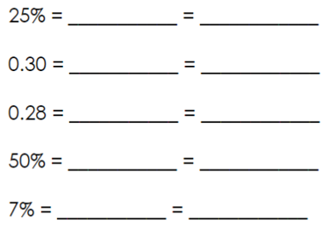

M: Modeling (I do)
- Teacher reviews how to complete an FDP (fraction, decimals and percents) table by doing 2 examples and assigning the rest to students
- RESOURCES FOR THIS LESSON [Page 1 bottom table]
  - When going from percent to decimal, move TWO places to the LEFT
  - When going from percent to decimal, move TWO places to the RIGHT
  - When going from fraction to percent
- Scale the fraction up or down to 100
- Convert the scaled fraction to a decimal by using place value
- Move the decimal point TWO places to the RIGHT

GP: Guided Practice (We do)
- Teacher reviews the first 1-2 problems of each section to model how students should complete it
- RESOURCES FOR THIS LESSON [Page 2-3]

Instructional Input - Synchronous
AS: Anticipatory Set (Introduction)
- Students warm up for today’s lesson should be 5 problems where students must complete all 3 forms: fraction, decimal and percent


M: Modeling (I do)
- Teacher reviews how to complete an FDP (fraction, decimals and percents) table by doing 2 examples and assigning the rest to students
- RESOURCES FOR THIS LESSON [Page 1 bottom table]
  - When going from percent to decimal, move TWO places to the LEFT
  - When going from percent to decimal, move TWO places to the RIGHT
  - When going from fraction to percent
1. Scale the fraction up or down to 100
2. Convert the scaled fraction to a decimal by using place value
3. Move the decimal point TWO places to the RIGHT

GP: Guided Practice (We do)
- Teacher reviews the first 1-2 problems of each section to model how students should complete it
- Fraction, Decimal, Percent Practice - [PAGE 5 AND 6] Target Level 1 students should begin on page 5, Level 2 students should begin on page 5 and Level 3 (high achieving) should begin on page 6
- AFTER completing page 6, students complete the matching cards activity starting in page 7-14 with partners
- Push students to ALWAYS simplify fractions - some students may be unable to, provide necessary scaffolding for those students

Independent Practice/ Homework
- Students complete the puzzle after the lesson and if not done then complete for HW - Fractions, Decimal and Percents Puzzle

Additional Problems:
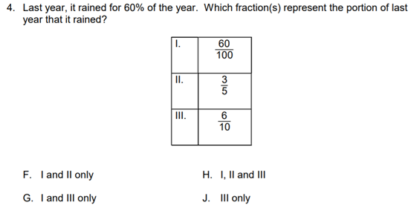

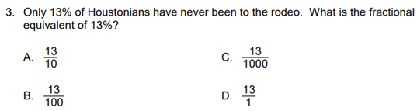
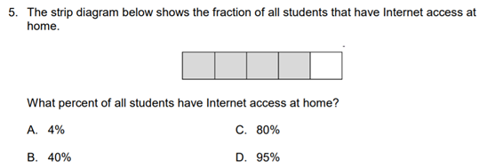
Lesson Close

Vocational
“Time is the most valuable thing a man can spend” - Theophrastus (Greek philosopher)

The term 'percent’ means ‘out of a hundred’. In mathematics, percentages are used like fractions and decimals, as ways to describe parts of a whole. When you are using percentages, the whole is considered to be made up of a hundred equal parts. Learning about percentages is another way to learn how to be a responsible individual regarding your time commitment to becoming financially independent. Think about the amount of time in percent form that you spend either reading a book, connecting with mentors or crafting your creativity through different outlets. What percent of time are you spending bettering yourself and others?

As a well-rounded individual it is important to set early habits that consistently splits your percentage of time to things that add value and meaning to your life. Whether that is reading a book, going to the gym, networking with professionals, working towards the future should be a priority of where your percentage of time and dedication should be focused on.

